Develop A Web Application Using Node-RED Service

|  |  |
| --- | --- |
| Team ID | PNT2022TMID45278 |
| Project Name | Real-time river water quality monitoring and control system |

Create An HTTP Requests To Communicate With Mobile App

Creating the HTTP request in Node-RED

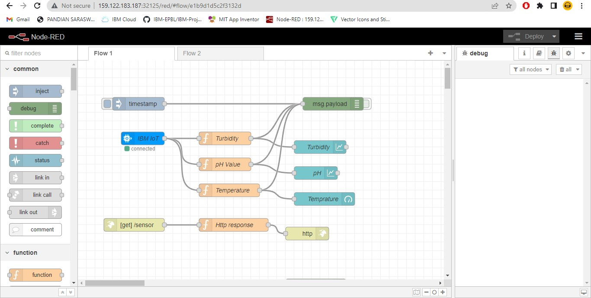

OUTPUT

Image 1

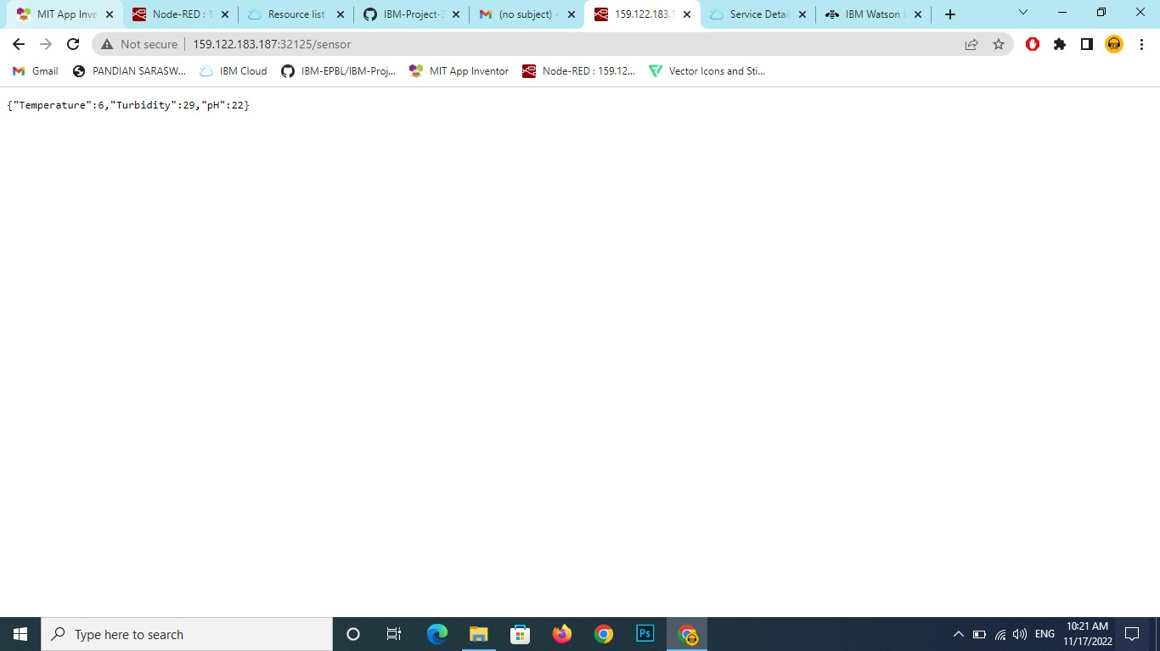

Image 2

